**Title:** Assessing geographic accessibility to public healthcare facilities using a raster-based approach: A case study of Uganda

**Background**

Geographic access to healthcare services in sub-Saharan Africa (SSA) exhibits considerable variation within and between countries, exhibited by prolonged travel times for populations to access facilities (1-3). Geographic inaccessibility significantly hampers healthcare utilization, affecting both infectious and non-communicable disease management (1, 2, 4). For instance, prolonged travel times and distance have been reported to be associated with lower vaccine uptake, diminished antenatal and postnatal care utilization, and reduced rates of screening, testing, and treatment for highly endemic infectious diseases in SSA like HIV, viral hepatitis B, malaria, and tuberculosis (5-7).

In 2016, the World Health Organization (WHO) outlined actionable strategies to achieve its targets for elimination or containment of such diseases, emphasizing the importance of enhancing accessibility to screening, testing, treatment, and educational services (8). It is there critical to investigate key indicators of healthcare accessibility, particularly barriers related to distance and travel time to healthcare facilities in resource-constrained settings. Such investigation can pinpoint underserved areas and inform the development of geographically targeted interventions to overcome barriers to healthcare access.

Thus, this pilot analysis aimed to assess the physical accessibility to public healthcare facilities in Uganda. Physical accessibility will be operationalized as travel time to the nearest public health facility. Notably, public health facilities cater to over 80% of the Ugandan population, distinguishing them as the primary healthcare providers in the country.

**Study objectives.**

* To determine traveling time to a nearest public healthcare facility in two distinct regions in Uganda
* To determine the spatial distribution of travel time to a nearest public healthcare facility in two distinct regions in Uganda

**Study methodology.**

**Study design and study area.**

This analysis aimed to quantify the geographical accessibility to public healthcare facilities within resource-constrained settings, with a focus on a selected country in sub-Saharan Africa. Specifically, the pilot analysis was conducted in two regions in Uganda with an intention of expanding the analysis to other regions and countries. Uganda is located in the Eastern region of Africa and spans approximately 93 square miles. It has a population of ~ 40 million people, predominantly residing in rural areas (9).

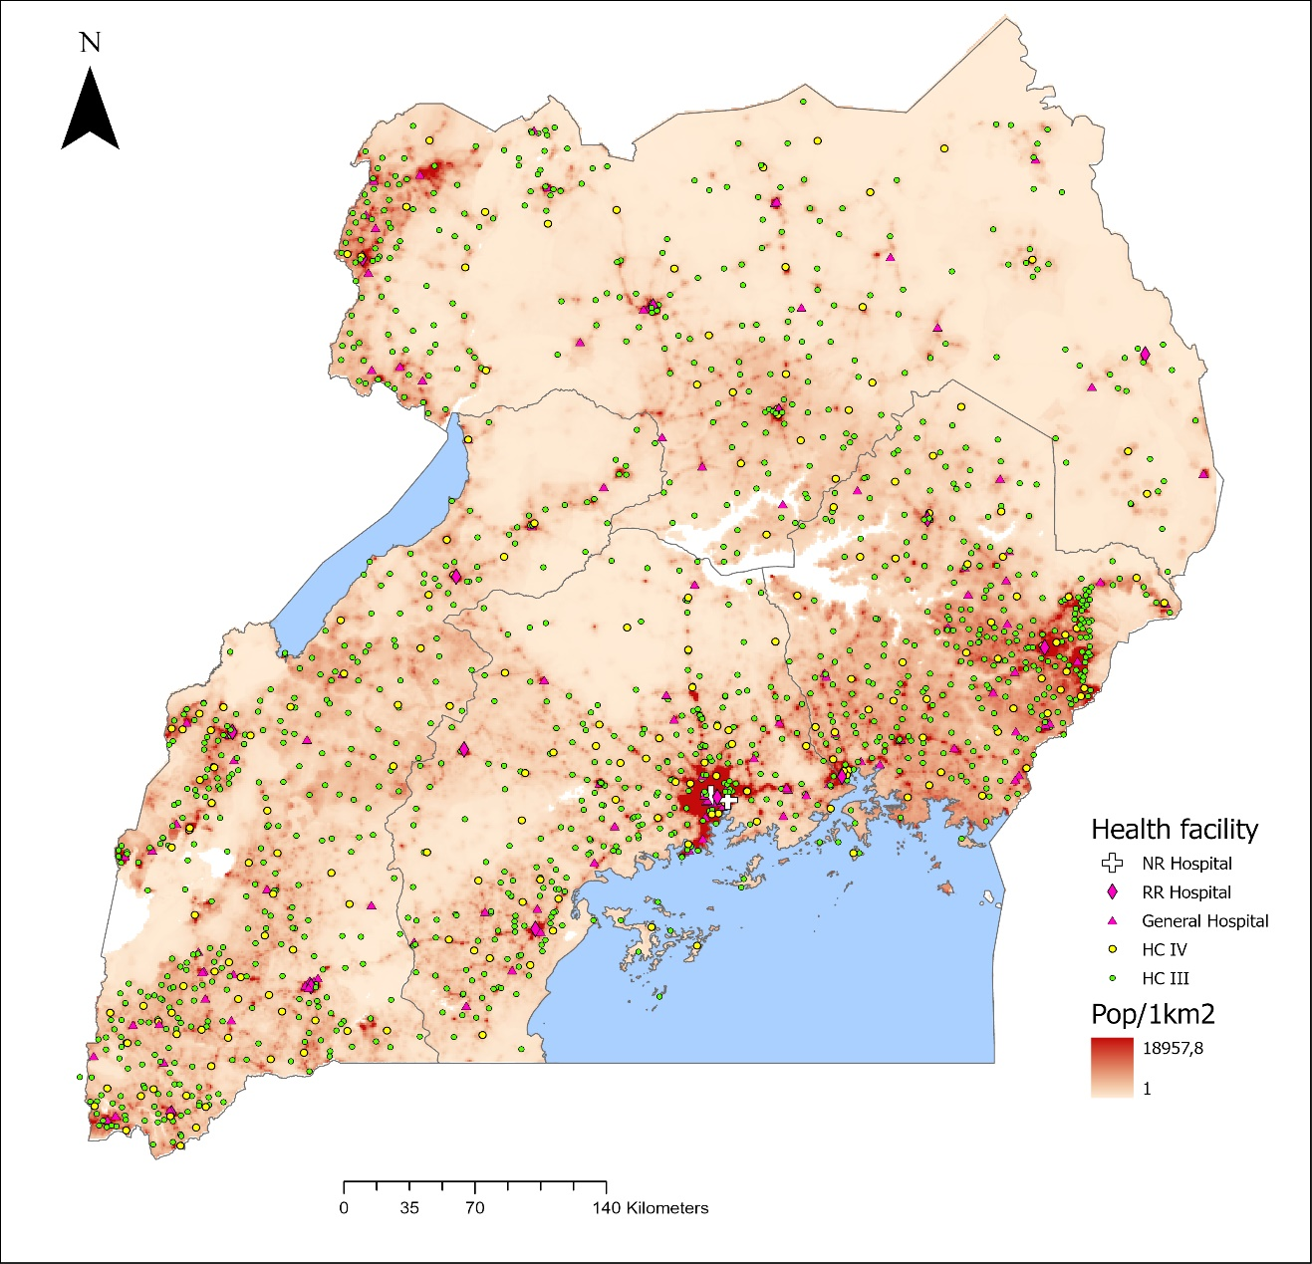

Figure 1: Study area -Uganda with health facilities locations and Population density.

Uganda's healthcare system operates via a decentralized referral framework, wherein the Village Health Team (VHT) serves as the initial point of contact for basic healthcare at the local level (10). Subsequently, patients may be referred from VHTs to higher-tier Health Centre (HC) facilities (ranging from HC I to HC IV), and based on clinical complexity, onward referrals may occur to general hospitals, regional referral hospitals, or national referral hospitals.

**Data and data sources**

*Health facility data:* Data about health facilities was obtained from the Uganda Ministry of Health. The data includes, name of the facility, facility level, ownership, geographic coordinates, region, and district where the facility is located.

*Road network data:* Road network data was obtained from the open-source Open Street Map data. The data was extracted using osmextract package in R software. The roads will be classified as primary, secondary, and tertiary roads. Because of data availability and accuracy issues, this analysis will only use primary, secondary and tertiary roads. Primary roads are basically high-volume roads that connect different regions within the country and also connect to country borders. Secondary roads feed into primary roads and connect smaller and major towns within the country. Tertiary roads feed into secondary roads and connect to residential areas.

Other datasets used such as DEM, landcover, administrative boundaries and barriers to movement are described in the Table 1.

Table 1: **Data variables to be used in the analysis.**

|  |  |  |
| --- | --- | --- |
| Variable | Data type | Sources |
| Health facilities | Vector data | Ministry of health |
| Road network | Vector | OSM |
| Landcover data | Raster, 100 m | Uganda sentinel 2 land use land cover data, from Sentinel-2 global land cover data; Copernicus |
| Administrative boundaries | polygon | Uganda Bureau of Statistics with support from WHO |
| Travel scenarios | Table | Adopted from Hierinks et al (2022) |
| DEM | Raster, 30m | Africa geoportal. Prepared by The Shuttle Radar Topography Mission data |
| Barriers to movement: lakes and rivers | Vector | ICPAC Geoportal |

**Data preparation**

Data preparation entailed thorough cleaning, clipping layers, layer projections and validation to ensure completeness of the input data. Accuracy and completeness checks was conducted on both health facility and road network datasets, and omissions were made where necessary. Data processing and management tasks will be executed using R. Figure 2 summarises the core steps followed in this analysis.

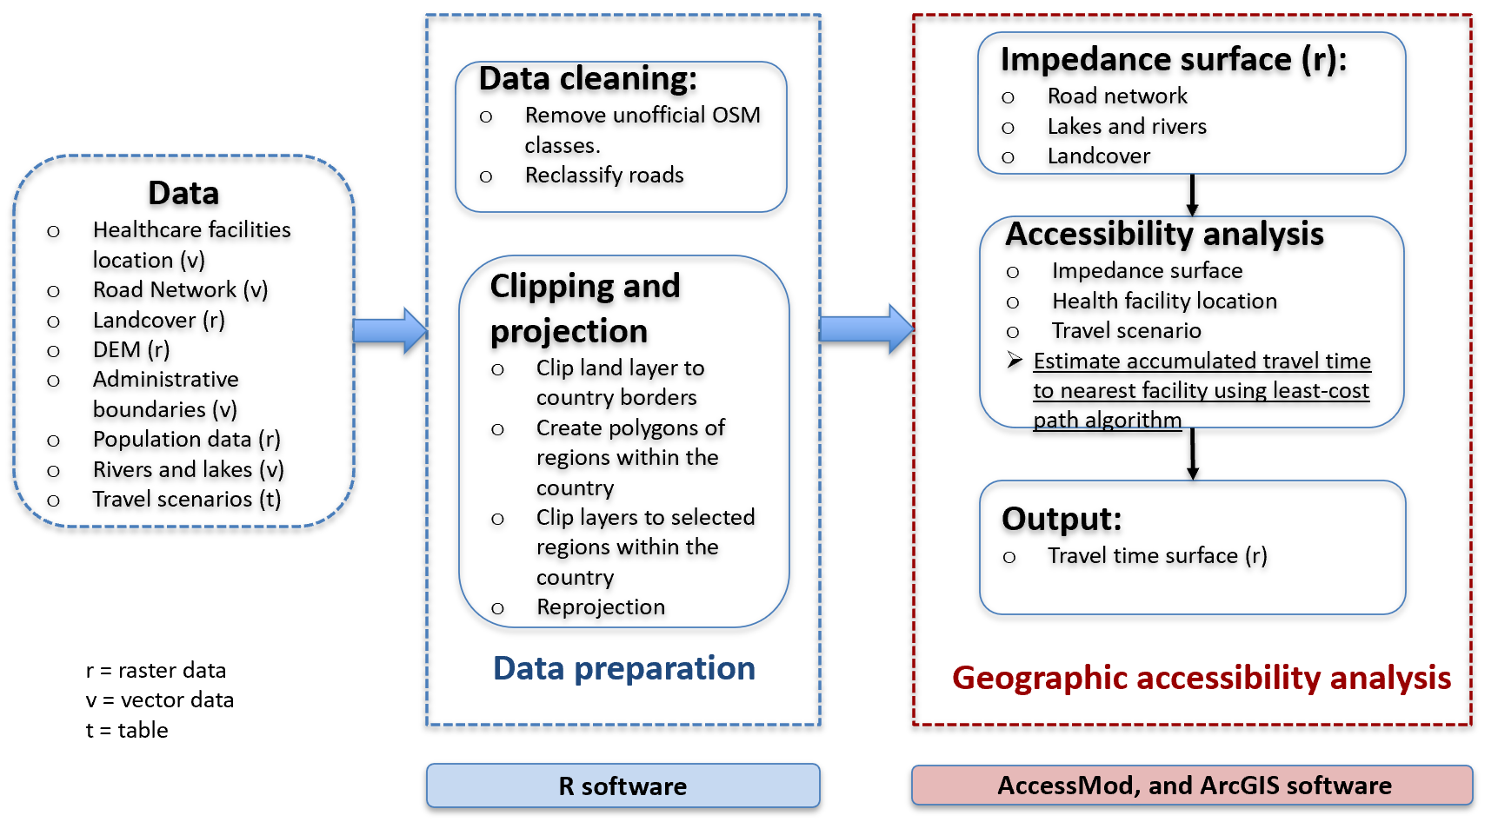

**Figure 2: Analysis workflow.**

**Geographic accessibility analysis**

Geographical access to public health facilities was calculated using a cost distance algorithm, which models walking and driving travel times to the nearest healthcare facility (1, 10). This involved creating a raster surface to calculate travel times to public healthcare facilities (HC III, HC IV, General Hospital, Regional Referral Hospital, or National Referral Hospital). Two main travel scenarios (travel modes) were computed for each facility (walking and driving scenarios). The estimated travel speeds under each travel model were adopted from Hierinks et al. (2022) (2) and other previous studies (1, 10-12), but some customised to the context of this analysis (Table 2). The road networks, land cover surface and barriers to movement (lakes and rivers) as well as their associated travel scenarios were used to generate a travel impedance surface. The impedance surface represents information about potential barriers on a patient’s journey to a health facility, which could include land cover types, barriers to movement, travel mode (driving or walking) and the road network (2).

**Table 2:** **Example of Travel scenarios:** *customised based on scenarios from Hierinks et al. (2022) (2)*

|  |  |  |
| --- | --- | --- |
| Landcover | Speed (km/h) | |
| **Walking Scenario** | **Driving Scenario** |
| Primary Road | 6 | 100 |
| Secondary Road | 6 | 50 |
| Tertiary Road | 6 | 30 |
| Forests | 2 | 2 |
| Shrublands | 2 | 2 |
| Grassland | 5 | 5 |
| Cropland | 4 | 4 |
| Regularly Flooded Areas or Aquatic Vegetation | 0 | 0 |
| Sparse Vegetation and Mosses | 3 | 3 |
| Bare Areas | 5 | 5 |
| Built up Areas | 5 | 5 |
| Open Water | 0 | 0 |

The impedance surface, coupled with the locations of public health facilities, was utilized to calculate the travel time in minutes to the nearest facility. This analysis was conducted using AccessMod version 5.8 software, an open-source web-based software developed by the WHO Department of Health Systems Governance and Financing (WHO/HIS/HGF) to support Universal Health Coverage (UHC) by modelling geographic accessibility to healthcare. AccessMod's algorithm uses the impedance raster surface to estimate travel time to the nearest health facility by summing the cumulative time required to traverse all cells along the least cost path from the point of interest (centroid of the cell) to a public health facility (1, 2).

The travel time surface outputs from AccessMod were exported and visualised in ArcGIS Pro. Travel time was categories as <30 minutes, 30-60 minutes, 60-120 minutes, 120-180 minutes and >180 minutes. Areas with good accessibility was considered as those whose travel time was within 60 minutes.

**Results**

**Study regions.**

Geographic accessibility was evaluated across two regions: the Central Region (CR) and the Eastern Region (ER) of Uganda, as illustrated in Figure 3. The CR, where the capital city is situated, is primarily urban and characterized by a relatively high population density, particularly in and around the capital city. On the other hand, the ER is predominantly rural, although it includes sporadic small cities with comparatively higher population densities dispersed throughout the region, (Figure 3).

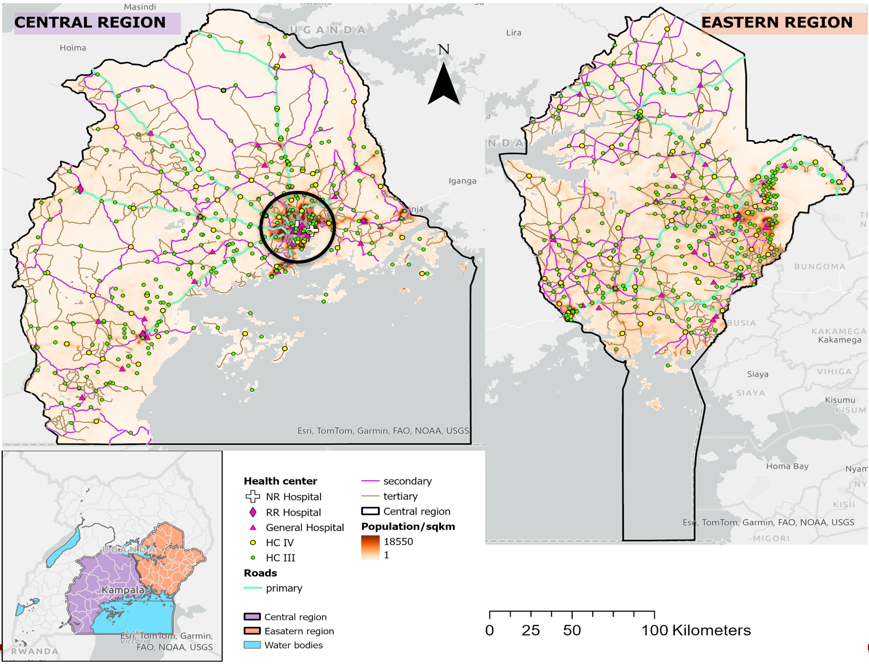

**Figure 3: Study regions. *Circled area in the capital city.**

The number of healthcare facilities in the two regions was relatively similar, although there was some variation in their distribution (Table 2). Specifically, in the CR, healthcare facilities were more concentrated in the capital city compared to other areas (Figure 3). In contrast, in the ER, healthcare facilities were generally uniformly distributed, with the exception of some areas with a high population density.

**Table 3: Summary of Public health care facilities used in this analysis.**

|  |  |  |
| --- | --- | --- |
| Healthcare facility type | Central region | Eastern region |
| National referral hospital | 2 | 0 |
| Regional referral hospital | 3 | 3 |
| General hospital | 35 | 29 |
| Health centre IV | 46 | 47 |
| Health centre III | 289 | 300 |

**Geographic accessibility analysis results**

**Central region.**

Overall, accessibility to healthcare facilities was better when considering the driving scenario compared to the walking scenario (Figure 4A, 5A). Additionally, regardless of the scenario, accessibility to healthcare facilities diminished (resulting in longer travel times) as one moves away from the capital city, as demonstrated in Figures 4A and 5A.

Areas within and around the capital city exhibited good accessibility, with most areas being within 30 minutes to 1 hour of driving time to a healthcare facility, as shown in Figure 4B. This pattern was similarly observed in the walking scenario, where at least most areas were within 1 hour of walking time to a healthcare facility (Figure 5B).

Conversely, areas farther from the city center experienced poorer accessibility, with most of these areas having travel times exceeding 1 hour to the nearest healthcare facility (Figures 4C and 5C). This discrepancy could be attributed to the spatial distribution of healthcare facilities in the region, where the density of the facilities decreases as one moves away from the capital city (Figures 3, 4A, and 5A)

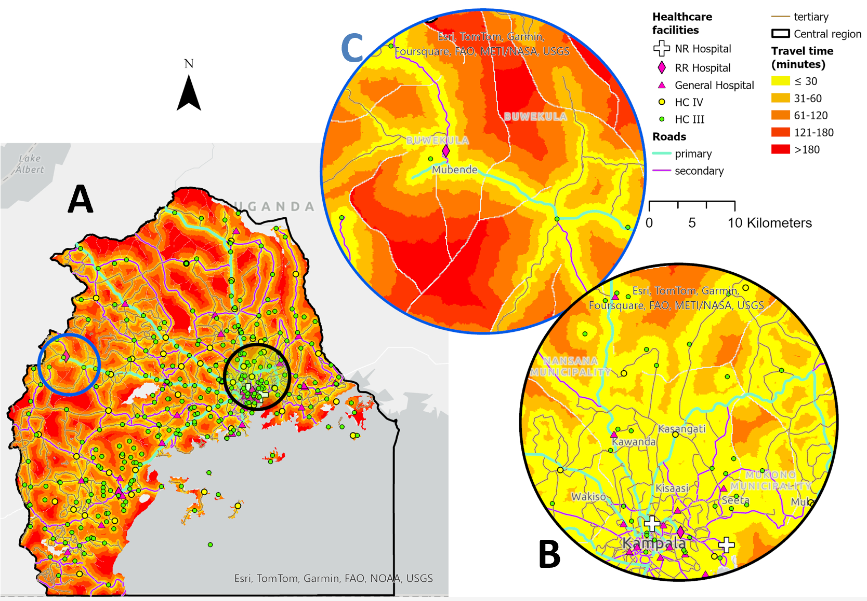

**Figure 4: Areas within different travel time from a nearest health care facility in the Central region (CR): By Driving.**

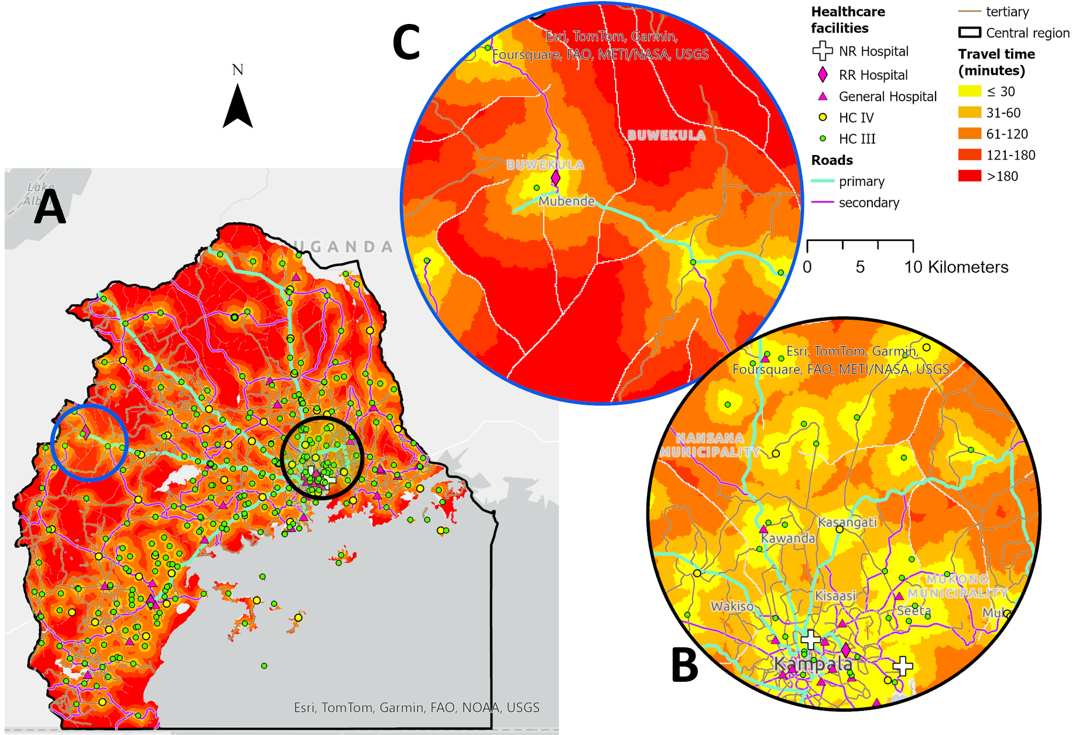

**Figure 5: Areas within different travel time from a nearest health care facility in the Central region (CR): Walking**

**Eastern region**

In the ER, the distribution of drive time was generally uniform, with most areas having a good accessibility to healthcare facilities (drive time within 1 hr) (Figure 6A). However, some patches of areas with travel times exceeding 1 hr were spread across the region (Figure 6B, 6C).

When considering walking scenarios, most areas exhibited poor accessibility (travel time exceeding 1 hour), illustrated in Figures 7A, B, and C. These findings suggest that individuals relying solely on walking for travel may face challenges in accessing healthcare facilities.

Given that the Eastern Region comprises mostly rural and suburban areas where access to vehicular travel modes is limited, many residents rely on walking or bicycling. Since accessibility under the driving scenario was generally good, a combination of driving (such as enhanced public transport) and walking could enhance accessibility in the Eastern Region.

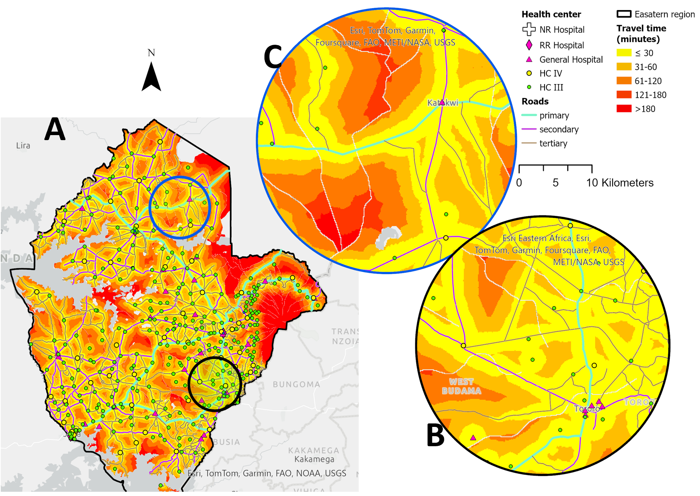

**Figure 6: Areas within different travel time from a nearest health care facility in the Eastern region: By Driving**

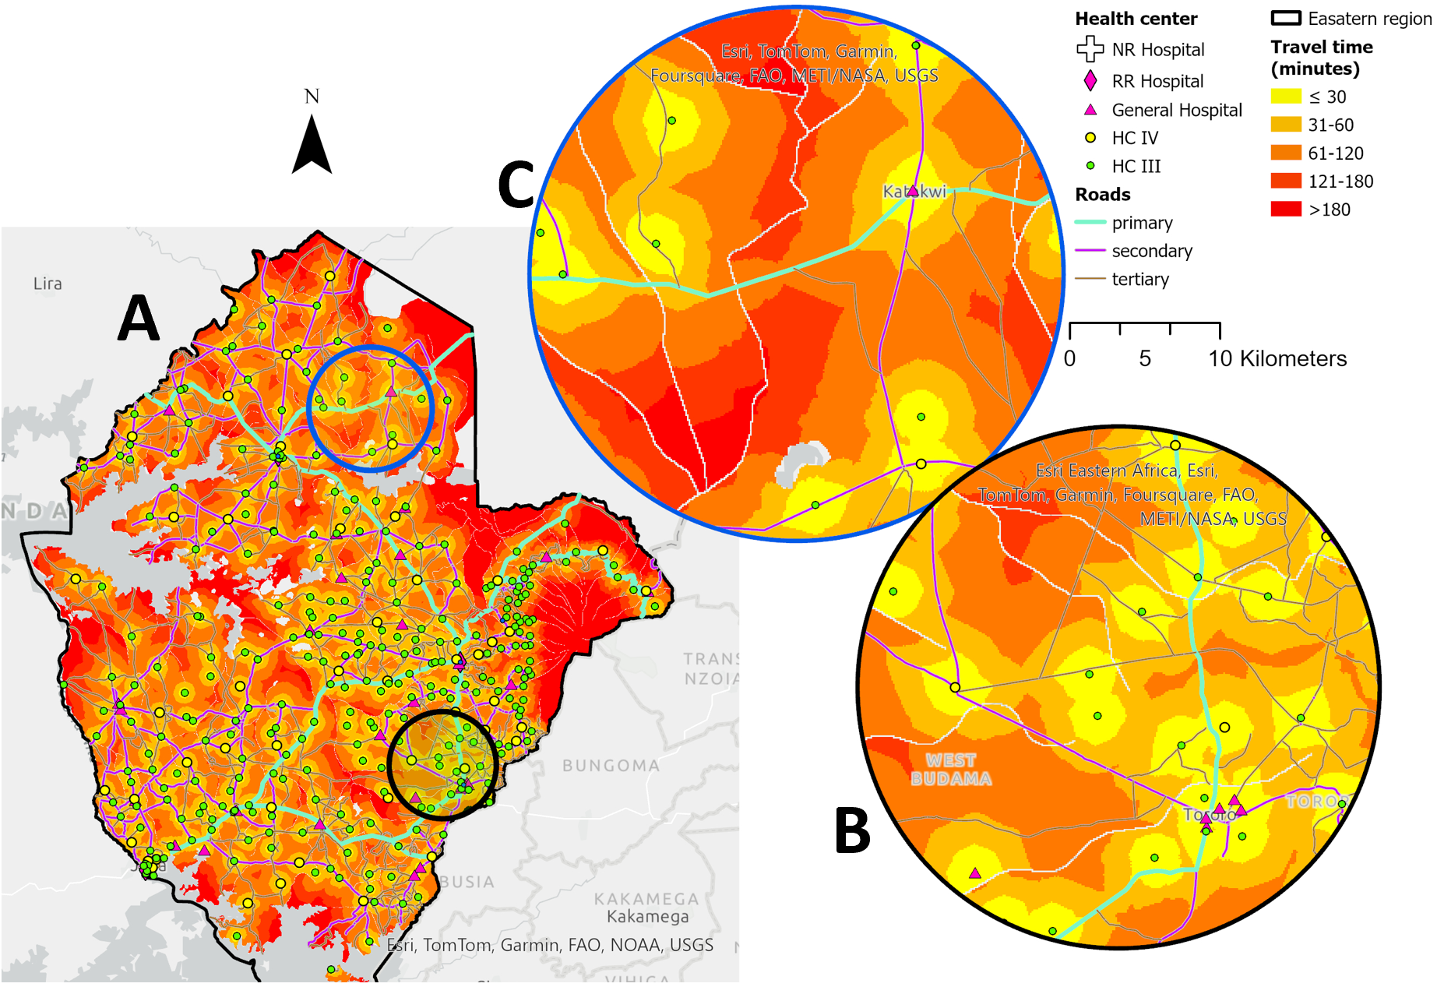

**Figure 7: Areas within different travel time from a nearest health care facility in the Eastern region: By Walking**

**Relevance of this analysis.**

This analysis holds significant relevance as it delved into a crucial aspect of healthcare service provision: geographic accessibility to healthcare facilities. By examining travel time to health facilities, the analysis highlighted the level of accessibility to healthcare services across two regions in Uganda. Geographic inaccessibility profoundly impacts healthcare utilization, including vital services such as screening, testing, treatment, and routine check-ups essential for maintaining good health.

The findings uncovered areas with inequitable access to services in both the CR and ER, which could inform targeted interventions to address healthcare access disparities. Additionally, considering two modes of travel (driving and walking) helped pinpoint areas that could benefit from improved provision of vehicular modes of transport, such as public transportation in both regions.

Furthermore, the output of this analysis, the travel time surface, could be intersected with the population distribution raster in order to assess geographic healthcare coverage (proportion of people with a given travel time from a healthcare facility). Hence aiding in identifying underserved areas. Additionally, the travel time surface could be linked with other sociodemographic and healthcare datasets, such as the Demographic and Health Surveys (DHS), in order to explore the association between travel time to a healthcare facility and various healthcare outcomes. This holistic approach could enhance our understanding of healthcare accessibility and can guide evidence-based policymaking and resource allocation in the healthcare sector.

**Limitations and some assumptions of the analysis**

Modelling geographic accessibility using a Raster-based approach is sensitive to factors such as travel speed and modes, as observed in this analysis where both driving and walking modes were considered (Figure 4A, 5A, 6A, 7A). In this study, travel speeds for the road network and land cover types were derived from literature sources, which generally reflect conditions in the study area. However, variations may exist, potentially impacting the accuracy of the model output. Conducting a sensitivity analysis involving variations in travel speed values by a certain percentage for different travel modes could help assess the impact of speed variations on the travel time output surface.

Furthermore, the resolution of the pixels in raster-based modelling is crucial. In this analysis, an impedance surface at a resolution of 100 meters was utilized. This resolution strikes a balance between computational efficiency and spatial detail, enabling the detection of small-scale disparities in access to healthcare facilities. However, the impact of changing resolution on the travel time output surface was not explored in this analysis.

Additionally, it's important to acknowledge the assumption made in this analysis regarding individual travel behaviour. Individuals were assumed to choose the shortest path between locations. Therefore, the travel time surface depicts the shortest time an individual would take to travel from the centroid of a pixel to the nearest healthcare facility. However, this assumption may not always hold true, as individual travel choices are influenced by various factors such as the availability of services, personal preferences, weather conditions, among others. Acknowledging these complexities in prospective analyses could provide a more nuanced understanding of geographic accessibility to healthcare facilities.

**References**

1. Ouma PO, Maina J, Thuranira PN, Macharia PM, Alegana VA, English M, et al. Access to emergency hospital care provided by the public sector in sub-Saharan Africa in 2015: a geocoded inventory and spatial analysis. Lancet Glob Health. 2018;6(3):e342-e50.

2. Hierink F, Boo G, Macharia PM, Ouma PO, Timoner P, Levy M, et al. Differences between gridded population data impact measures of geographic access to healthcare in sub-Saharan Africa. Communications Medicine. 2022;2(1):117.

3. Florio P, Freire S, Melchiorri M. Estimating geographic access to healthcare facilities in Sub-Saharan Africa by Degree of Urbanisation. Applied Geography. 2023;160:103118.

4. Organization WH. Primary health care measurement framework and indicators: monitoring health systems through a primary health care lens: World Health Organization; 2021.

5. Okwaraji YB, Mulholland K, Schellenberg J, Andarge G, Admassu M, Edmond KM. The association between travel time to health facilities and childhood vaccine coverage in rural Ethiopia. A community based cross sectional study. BMC Public Health. 2012;12(1):476.

6. Alene KA, Elagali A, Barth DD, Rumisha SF, Amratia P, Weiss DJ, et al. Spatial codistribution of HIV, tuberculosis and malaria in Ethiopia. BMJ Glob Health. 2022;7(2).

7. Martyn E, Eisen S, Longley N, Harris P, Surey J, Norman J, et al. The forgotten people: Hepatitis B virus (HBV) infection as a priority for the inclusion health agenda. eLife. 2023;12:e81070.

8. Organization WH. Global health sector strategies on, respectively, HIV, viral hepatitis and sexually transmitted infections for the period 2022-2030. 2022.

9. USAID. Uganda: Nutrition Profile. 2021.

10. Dowhaniuk N. Exploring country-wide equitable government health care facility access in Uganda. International Journal for Equity in Health. 2021;20(1):38.

11. Stewart BT, Tansley G, Gyedu A, Ofosu A, Donkor P, Appiah-Denkyira E, et al. Mapping population-level spatial access to essential surgical care in Ghana using availability of bellwether procedures. JAMA surgery. 2016;151(8):e161239-e.

12. Esquivel MM, Uribe-Leitz T, Makasa E, Lishimpi K, Mwaba P, Bowman K, et al. Mapping disparities in access to safe, timely, and essential surgical care in Zambia. JAMA surgery. 2016;151(11):1064-9.